**STUDENT’S BOOK 5C**

**page 94 exercise 3**

a) Dwayne Johnson was born in 1972. • b) He ended his football career because of an injury. • c) He loved wrestling and was very good at it. • d) He fell in love during high school. • e) He and his wife had a daughter in 2001. • f) Dwayne played in Fast and Furious in 2013. • g) He starred in Hercules in 2014 and Jumanji in 2017. • h) He won the Kid’s Choice Award for Favourite Movie Actor in 2008.

**page 95 exercise 5**

a) F, b) T, c) T

**page 95 exercise 6**

1)b, 2)a3)c 4)a5)a+b+c

**WORKBOOK 5C**

**page 56 exercise 1**

a) MOVED • b) LOVED • c) FINISHED • d) PLAYED • e) WANTED • f) STARRED

**page 57 exercise 2**

BE BORN - WAS BORN • FEEL - FELT • WIN - WON • FALL IN LOVE - FELL IN LOVE • BECOME – BECAME

**page 57 exercise 3**

win - won • become - became • fall in love - fell in love • feel - felt • have - had • be born - was/were born

**page 57 exercise 4**

1) d - Bruce Lee se narodil v roce 1940 v San Franciscu v Kalifornii. • 2) f - Jako malý hrál v několika filmech. • 3) c — Žil v Hong-Kongu s jeho rodiči. • 4) b - Přestěhoval se do USA, když mu bylo 18. • 5) a - Hrál v pěti amerických filmech. • 6) e - Jeho filmy byly o bojovém umění.

**page 58 exercise 5**

was born • had • loved • saw • became • finished • played • fell • started • starred • wanted • took on

**page 58 exercise 6**

a) T • b) F • c) T • d) T • e) F

**page 58 exercise 7**

7 a) won • b) moved • c) felt • d) wanted • e) had • f) fell • g) became • h) left

**page 59 exercise 8**

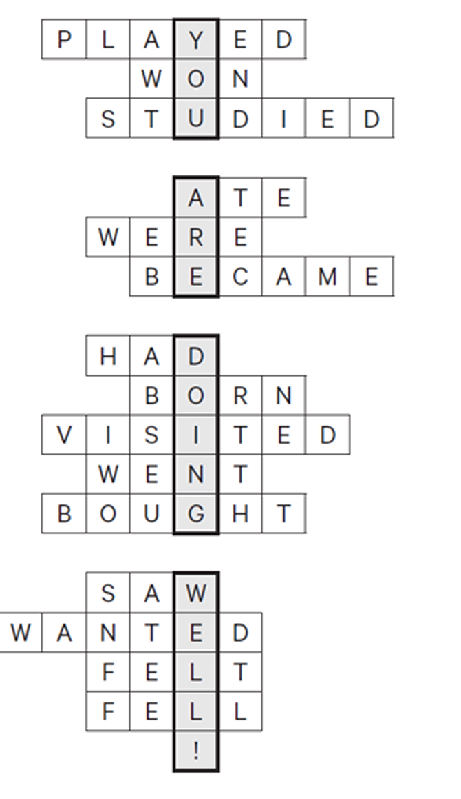

**page 59 exercise 9**

Odpovědi žáků se budou lišit.

**DVD: 28**

T: Hi guys! What’s up? Today I am making a Vlog about my idol.

Ch: Hey! It’s actually a presentation for school and Tom wants to show it to us before he presents it in front of the class.

T: Yes, actually, I get a little nervous when I have to talk in front of many people.

Ch: Don’t worry, there are just thousands of students watching our Vlog… You must be self-confident and start well!

T: Yes, so, my idols are footballers, for example Messi and Ronaldo.

Ch: Oh no, no footballers, please.

T: But I have decided to talk about my favourite singer. He was born on the 18th of March 1979 in Los Angeles, California. His family is Jewish. He also is a songwriter, composer and a record producer.

Ch: Wait, wait, this was too fast. You have to speak clearly and slowly. Did you say he was Swedish?

T: No, his family is Jewish. He is American, from Los Angeles, California.

Ch: I got this. But he is a singer and...?

T: A composer, songwriter and a record producer…

Ch: This was much better!

T: His parents got divorced when he was seven. He has a brother, a stepbrother and two stepsisters. He began his music career in 1994 when he started as a lead singer and a guitarist in the band called Kara’s Flowers.

Ch: What was the name of the band? I didn’t get it.

T: Kara’s Flowers. K-A-R-A-S

Ch: OK, you don’t have to spell it. I’m not stupid.

T: In 2002 he recorded the album Songs about Jane with a new group called Maroon 5 and he became successful and famous.

Ch: Maroon 5?

T: Yes, Maroon 5. Do you know their songs? For example, Sugar, Animals and Moves like Jagger.

Ch: Of course, I know Maroon 5. But what is his name?

T: Adam Levine.

Ch: Yes, Adam Levine. Do you know that the People Magazine called him the sexiest man alive in 2013?

T: Did they? I don’t care. I’m not a girl.

Ch: I also think that he is smart and handsome.

T: Are you in love with him?

Ch: No way! He’s your idol!

T: Yes, because I like his music. It’s positive. He’s not only a wonderful singer. In 2012 he acted in the American TV series American Horror Story and in the film Love Song. He has got a recording company called 222 Records. He designed a fashion collection for KMarkt and ShopYourWay.Com.

Ch: Are you reading it or do you remember it?

T: No, no, I remember it!

Ch: Cool! That’s much better. I understood everything. Now you can present it to the class.

T: And you? What do you think? Was my presentation good? Adam Levine is my idol and he is so cool. Do you have an idol?